**TECH GIANTS – MOST VALUABLE PUBLICLY TRADED COMPANIES** (7 min read)

As technology inculcates artificial intelligence, West Coast tech giants have not refrained from holding back their growth. Tech companies have managed to create high revenue floods to boost their expansion in the market and they do so in numerous ways. In this article we aim to depict how and why tech giants have taken over as the most valuable publicly traded companies. We have used certain graphs and visualizations to depict data as it would make it easy for us to gain insights. Four companies: Amazon, Apple, Facebook and Microsoft are selected as they qualify as a tech giant which is backed by figures in the given chart (fig1). For all the companies, the ring statistical infographics[1] is used to depict the revenue proportion of three tech giants: Amazon, Apple, Facebook and Microsoft. This info-graph essentially displays how the company has broken down its revenue scheme. The larger portion of the ring represents greater revenue and vice versa. Statistical figures for the same are given besides it.

**Figure 1**

*Tech Companies Revenue and Capex*

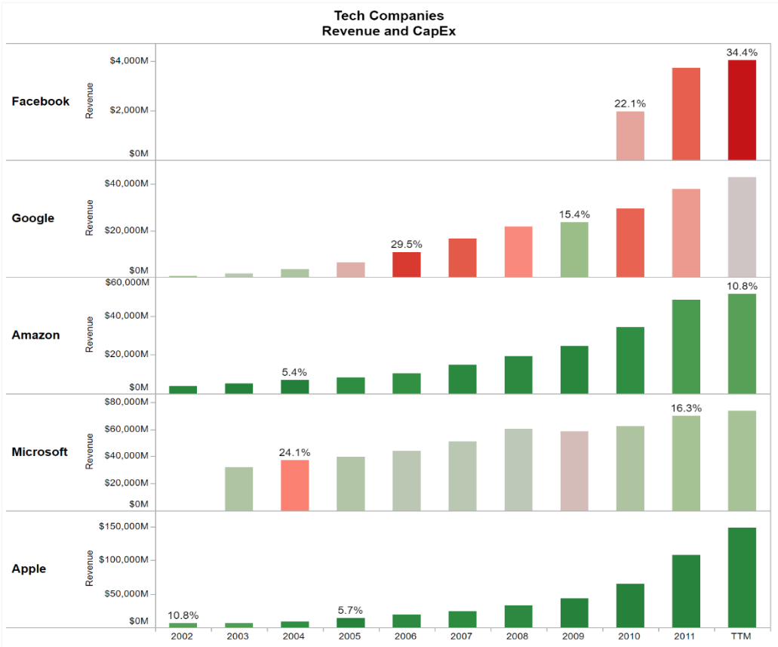

*Note. [2]*

**Amazon:** Currently, Jeff Bezos’s Amazon is valued USD 1.7 trillion. It is impossible to state what Amazon is as a company owing to the multitude of sectors it operates in. The online retail giant which started as a bookstore from a garage has grown up to the turnover of $232.9 billion annually as of 2018, depicted in the graph below.

**Figure 2**

*Revenue scheme of Amazon*

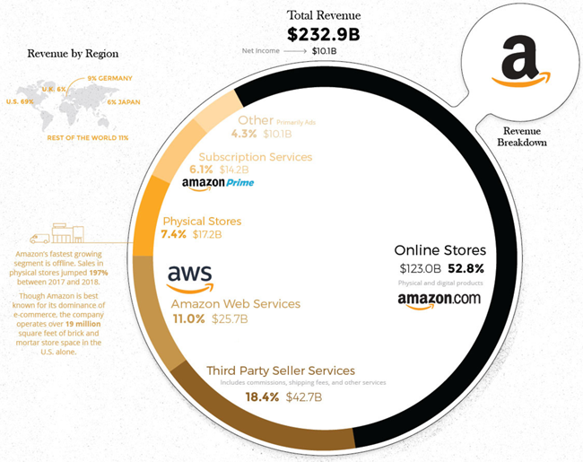

*Note. [3]*

Amazon’s turnover comprises of a vast portfolio of revenue stream ranging from its online retail store to its web services. Most of its revenue comes from the retail section which accounts for 52.8% of its revenue whereas its physical stores have seen it become its fastest growing segment with 7.4% revenue proportion. This is seen as a growth of 197% from the last year offline sales recorded by Amazon. [4] The new segment identified by Amazon as its most profitable segment is Amazon Web Services, contributing about 11% in the turnover, which encourages business start-ups. Moreover, the Prime Video streaming service offered is very impressive with reach in over 200 countries, while spending fewer dollars than Netflix – its major competitor – to produce original content. Its shipping and logistics services – *Fulfilment by Amazon* – is an already booming segment that allows small businesses to tap into the scale of

**Figure 3**

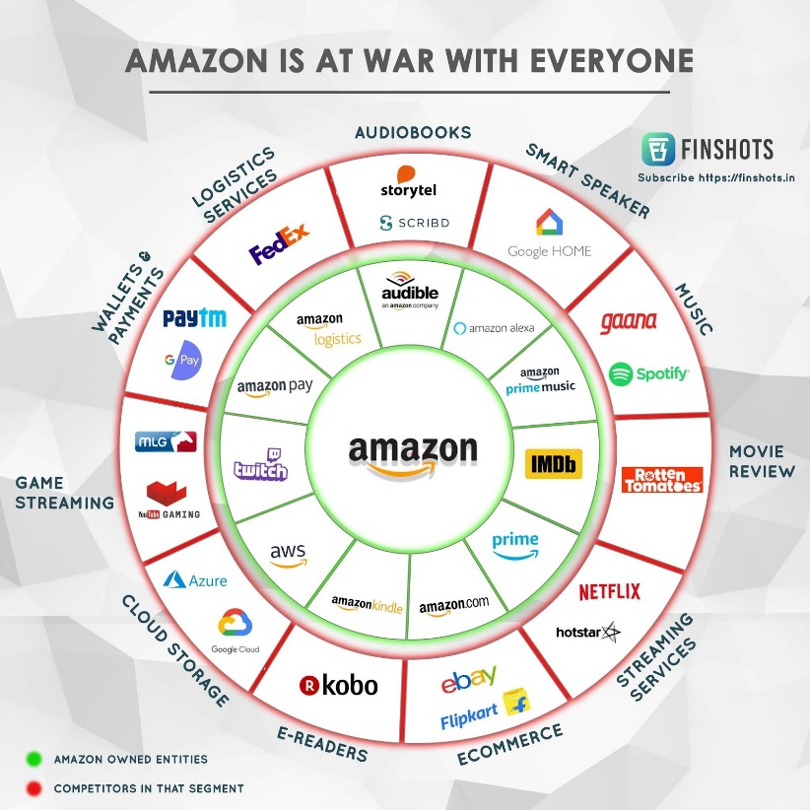Amazon. Investing in this segment also betters the customer experience which is a key objective for Amazon’s growth.[5] The info-graph given here depicts the range of Amazon products and its competitors. It shows that Amazon has moved its expansion into gaming platforms along with cloud services. Even though it may only have a small market share at present, Amazon has gained high interest to take over the leading spot in many industries from its competitors.

*Note*. [6]

**Apple:** Apple is one of the most successful companies in the world, co-founded by Steve Jobs and Steve Wozniak, in 1977. Apple's success lies in a strategic vision that transcended simple desktop computing to include mobile devices and wearables. Both performance and design are key drivers of the Apple brand and its ongoing success. It is worth more than any other publicly traded company, with a market value near $1.1 trillion. It is the most profitable, bringing in $265.6 billion in revenue.[7]

**Figure 4**

*Revenue scheme of Apple*

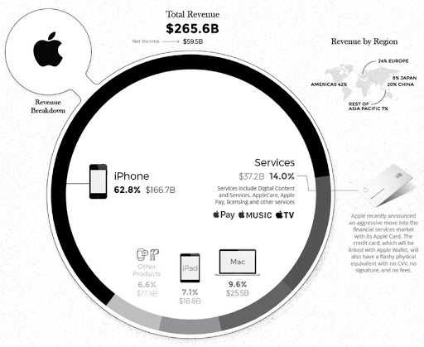We can infer from the given graph that, iPhone has contributed about 62.8% of Apple's revenue of total sales. Apple’s growing services segment made up approximately 14% of revenue, ahead of the Mac, which generated 9.6% of total revenue. The wearables, home and accessories segment comprised 6.6% of sales and the iPad accounted for 7.1% of the total revenue.

*Note*. [8]

Revenue by Region:

**Figure 5**

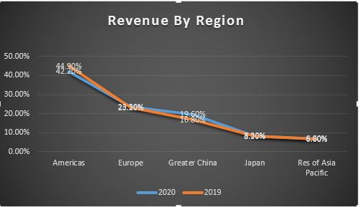

Given is a line chart, showing revenue by regions of Apple for different regions of the year from 2019 to 2020.

**Table 1**

|  |  |  |
| --- | --- | --- |
| REVENUE BY REGION | | |
| Region | Revenue | Reason |
| America | Net sales increased from 42.2% to 44.9% | Main reason for it is due to higher Services and Wearables, Home and Accessories net sales, partially offset by lower iPhone net sales because of the COVID-19 pandemic.  Moreover, the weakness in foreign currencies relative to the U.S. dollar had a significant unfavourable impact on the country specific net sales during 2019. |
| Europe | Net sales decreased from 23.5% to 23.2% |
| Greater China | Net sales decreased from 19.6% to 16.8% |
| Japan | Net sales decreased from 8.2% to 8.3% |
| Rest of Asia Pacific | Net sales increased from 6.6% to 6.8% |

Today, Apple leads the world in innovation with iPhone, iPad, Mac, Apple Watch, and Apple TV. Apple’s five software platforms — iOS, iPadOS, macOS, watchOS, and tvOS — provide seamless experiences across all Apple devices and empower people with breakthrough services including the App Store, Apple Music, Apple Pay, and iCloud.

**Facebook:** Next, we probe into Facebook’s burgeoning revenue, widening geographical reach targeting audience from diversified age groups.

**Figure 6**

*Revenue scheme of Facebook*

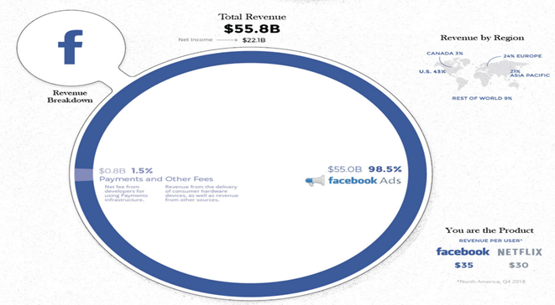Facebook, a pioneer in the field of social media is still growing exponentially. To get a perfect insight, infographic graphs depicting the tech giant’s revenue and growth are meticulously studied here. Its operations are not always efficacious as sometimes businesses take a hit and tumble to the ground. The company has sailed a long course through the years avoiding hindrances or succumbing to them.

*Note*. [9]

In the above representation, the revenue structure of Facebook is clearly given. The parts of the ring represent the revenue collected by rendering different services and the magnitude of each varies as per the amount of revenue raked in. Very evidently, it can be said that advertisements are a major source of revenue ($55.8B~98.5%) followed by revenue from other source ($0.8B~1.5%).

Given is a column chart, showing ARPU of Facebook for different geographical areas spread across a timeline from 2016 to 2020 (quarterly division).

**Figure 7**

*ARPU of Facebook (2016-2020)*

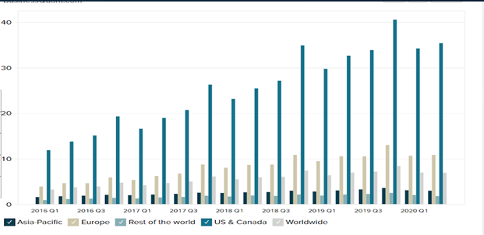

*Note*. [10]

Looking back at third-quarter earnings from Facebook and its rivals, Facebook’s dominance in social media is as clear as ever, and there is no better metric to illustrate that fact than average revenue per user (ARPU). The company’s high ARPU, which is calculated by dividing quarterly revenue by number of users in the period, shows that consumers were willing to accept more ads on Facebook without abandoning it, and that the company could keep charging premium prices to advertisers.

Facebook’s continuing financial strength is primarily the result of its ability to hang onto users through a tumultuous 2018, when the hashtag “Delete Facebook” trended on multiple occasions. Monthly active users increased 8% from a year earlier to 2.45 billion, making it many times bigger than any of its competitors. This toll led Facebook to record its highest ARPU in the 2019 Q3. The ARPU of $8.38(worldwide) was the highest recorded.[11]

**Conclusion**

All in all, throughout the article we can see clearly see how tech giants like Amazon, Apple and Facebook have slowly taken over as the most valued publicly traded companies. Moreover, these visualisations provide us with a better understanding of the facts and figures that revolve around these companies.

TEAM 1

1. (Desjardins, 2019). How the tech giants make their billions. Visual Capitalist. <https://www.visualcapitalist.com/how-tech-giants-make-billions/>
2. (Lemos, 2020). Tech Companies Revenue and Capex. Free Data Visualization Software | Tableau Public. <https://public.tableau.com/profile/alexandre.rosseto.lemos#!/vizhome/TechCompanies_15871522262850/Sheet2>
3. Desjardins, J. (2019, March 29). How the tech giants make their billions. Visual Capitalist. <https://www.visualcapitalist.com/how-tech-giants-make-billions/>
4. Mohsin, M. (2020, April 7). 10 Amazon statistics you need to know in 2021. Oberlo | Where Self Made is Made. <https://www.oberlo.in/blog/amazon-statistics>
5. (Desjardins, Visual Capitalist, 2017). Infographic: Breaking down how Amazon makes money. Visual Capitalist. <https://www.visualcapitalist.com/breaking-amazon-makes-money/>
6. (Finshots, 2019). Amazon is at war with everyone. <https://finshots.in/infographic/amazon-is-at-war-with-everyone/>
7. (Inc., 2020). SEC.gov. <https://www.sec.gov/Archives/edgar/data/320193/000032019320000052/a10-qq220203282020.htm>
8. (Desjardins, Visual Capitalist, 2019). How the tech giants make their billions. Visual Capitalist. <https://www.visualcapitalist.com/how-tech-giants-make-billions/>
9. (Desjardins, Visual Capitalist, 2019). How the tech giants make their billions. Visual Capitalist. <https://www.visualcapitalist.com/how-tech-giants-make-billions/>
10. (Tejashwini, 2020). Â�¢ Facebook: Average revenue per user (ARPU) by region. Business Quant. <https://businessquant.com/facebook-average-revenue-per-user-by-region>
11. (Rodriquez, 2019). Why Facebook generates much more money per user than its rivals. CNBC. <https://www.cnbc.com/2019/11/01/facebook-towers-over-rivals-in-the-critical-metric-of-revenue-per-user.html>